For immediate release:

Canadian Brass PERFECT LANDING CD
November 2015

Canadian Brass makes its perfect landing with this sequel to its award winning CD “Takes Flight.” From the exuberant Piccolo Trumpet notes of Bach’s Brandenburg Concerto to the mesmerizing music of Spain, Canadian Brass takes their listeners on a fantastic musical journey that only they can deliver.
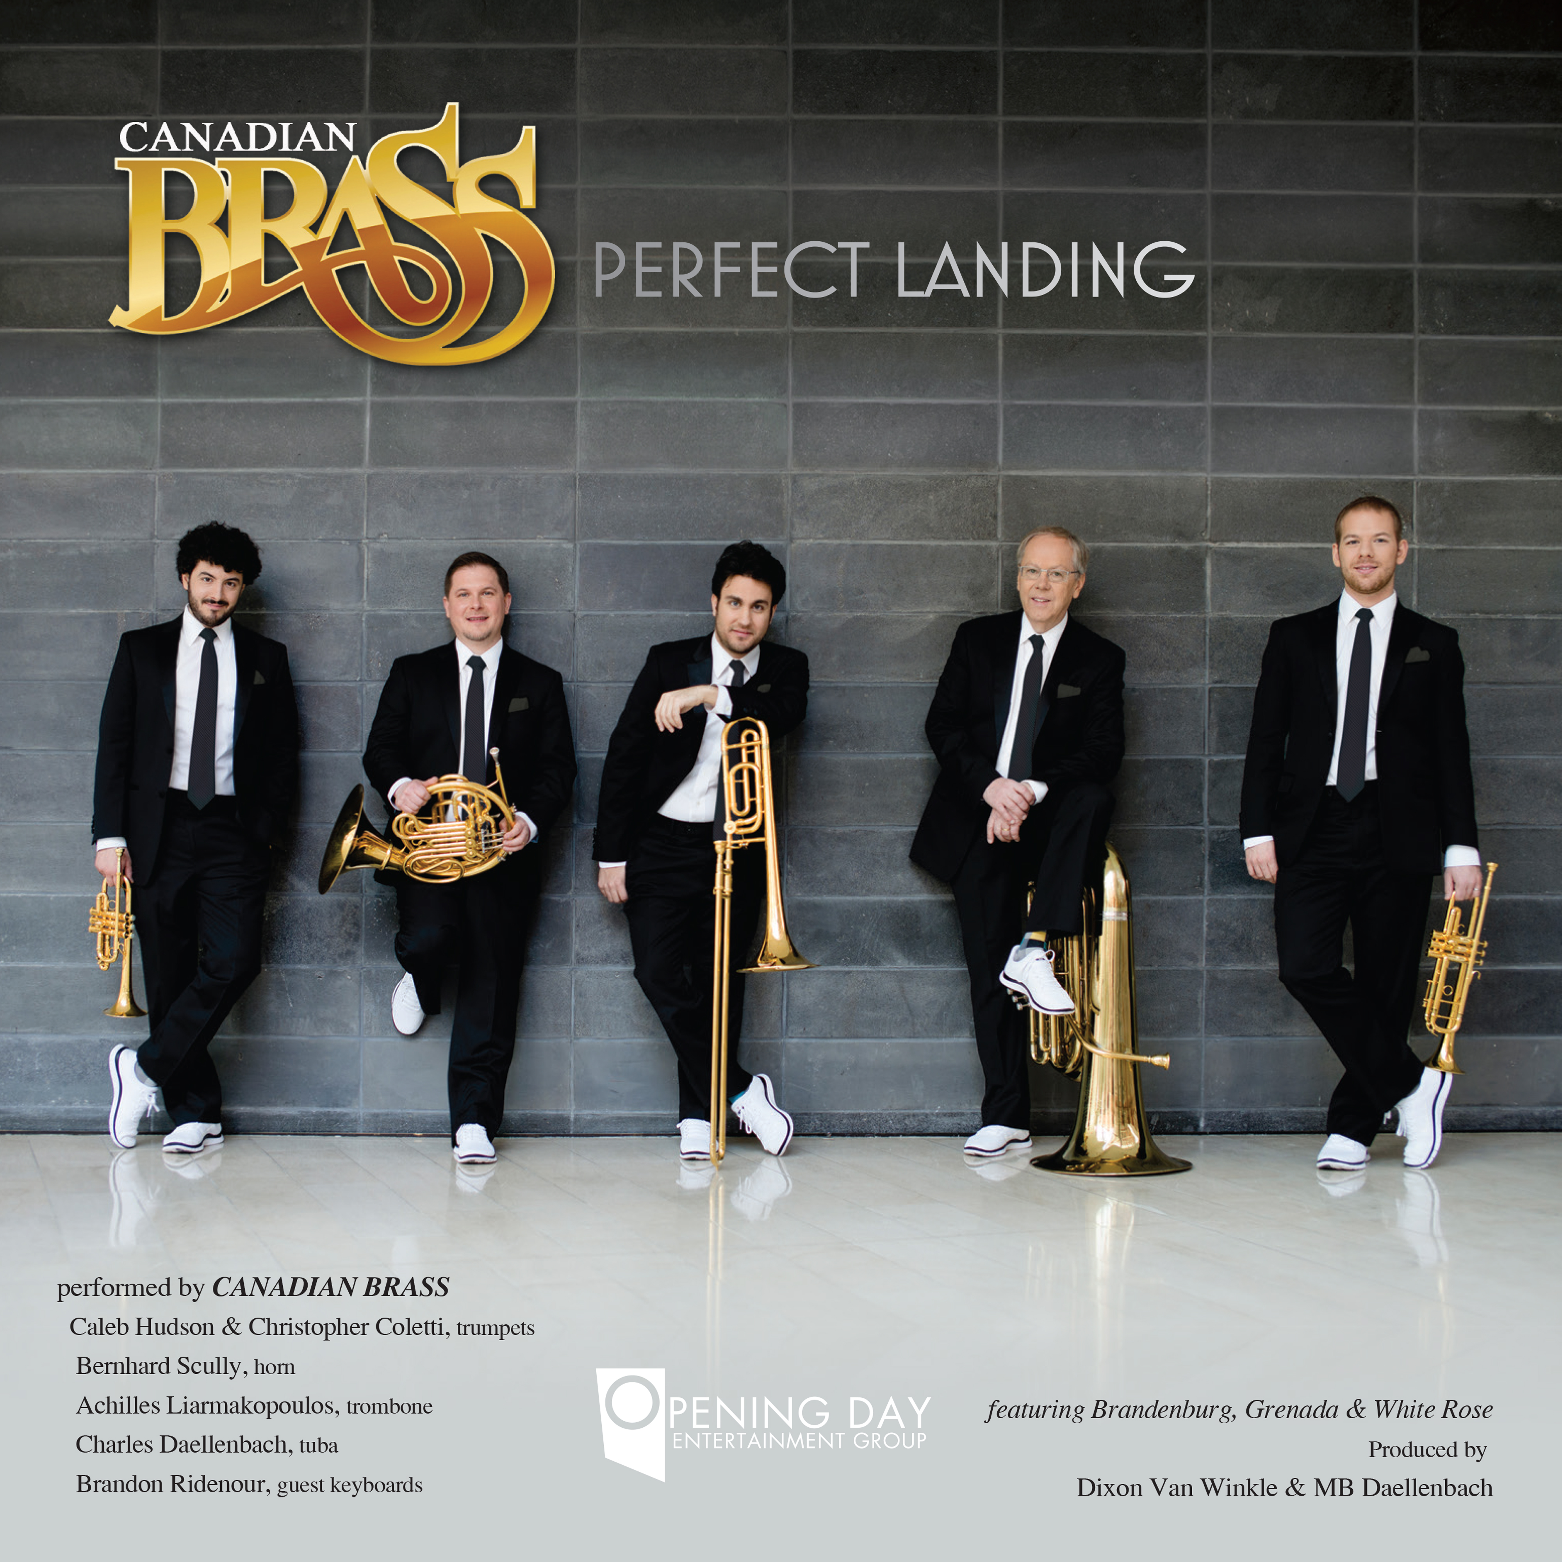
Continuing on its serendipitous musical journey, the group is ‘on the ground’ surrounded by the preeminent forces in the music world today: IMG Artists, MuenchenMusik & Harrison-Parrott talent agencies, Hal Leonard publishing corporation, Linus Entertainment, Conn & Bach instruments, and the powerhouse in music education ... the Conn-Selmer Institute. The repertoire chosen for this album represents the strength and beauty of all these forces landing together in total harmony.
Canadian Brass has been at the forefront of innovation in the chamber music world for over forty-five years. Having brought an entirely new concert presentation experience to listeners around the globe, the ensemble is credited with the flood of interest in brass concerts, in the awareness and expansion of brass repertoire, and in the newfound commitment to their education platform.

Connect with canadianbrass.com on
Facebook, Twitter, Instagram & YouTube for all news and video clips.

